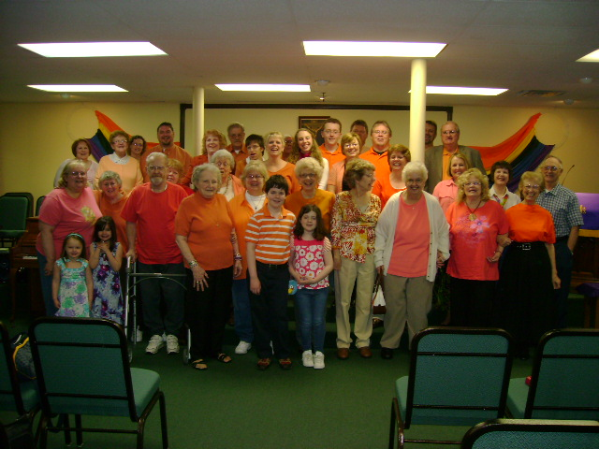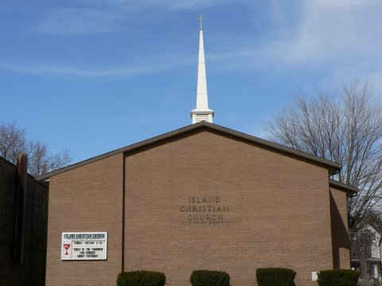



**Island Christian Church**

**(Disciples of Christ)**

***www.island-christian-church.org***



We are Disciples of Christ, a movement for wholeness in a fragmented world. As part of the one body of Christ, we welcome all to the Lord's Table as God has welcomed us

[**www.facebook.com/pages/**](http://www.facebook.com/pages/)

**Wheeling-Island-Christian-Church-Disciples-of-Christ/**



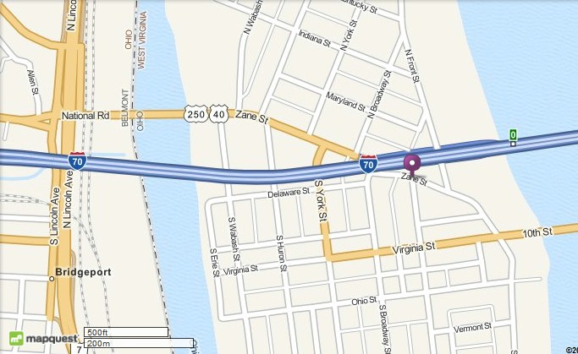

From the West: drive east on National Road (State Road 40/250) across the Bridgeport Bridge to Wheeling Island. Travel east on Zane Street though two (2) traffic lights, then turn left onto North Broadway Street and then turn immediately right into the ally. From the East: drive west on Interstate 70 and take Exit 0 (Wheeling Island). At the bottom of the off-ramp, turn right onto North Broadway Street and then turn immediately right into the ally. Follow the ally to parking and the entrance to the church.

**WE ARE FAMILY!!**

**The Island Christian Church is NOT just a church, but a church FAMILY, serving families and friends from Wheeling Island and surrounding communities. We invite you to come and visit, worship and share fellowship. *SEE FOR YOURSELF THAT YOU!!***

**ISLAND CHRISTIAN CHURCH**

**(Disciples of Christ)**

**59 Zane Street, P.O. Box 1144**

**Wheeling WV 26003**

**(304) 232-0640**

**Service Begins at 9:30 am Each Sunday**

**(weather permitting)**





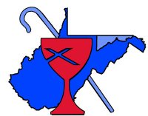

**West Virginia Disciples**

***www.wvdisciples.net***

**Christian Church**

**Disciples of Christ**

***www.disciples.org***

**WE ARE THE CHURCH THAT CHOOSES TO BE *“ALIVE”…* NOT JUST SURVIVE!!**

**59 Zane Street, Wheeling WV 26003 – (304) 232-0660**

***Worship service begins at 9:30 am every Sunday***



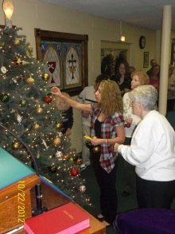

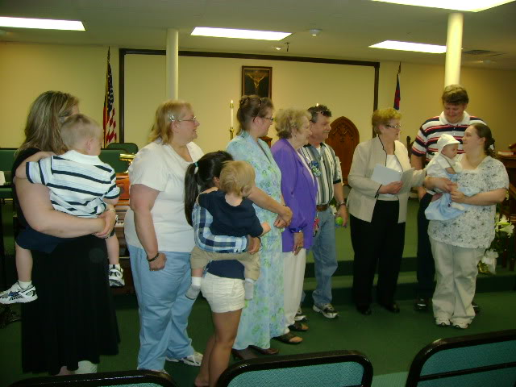

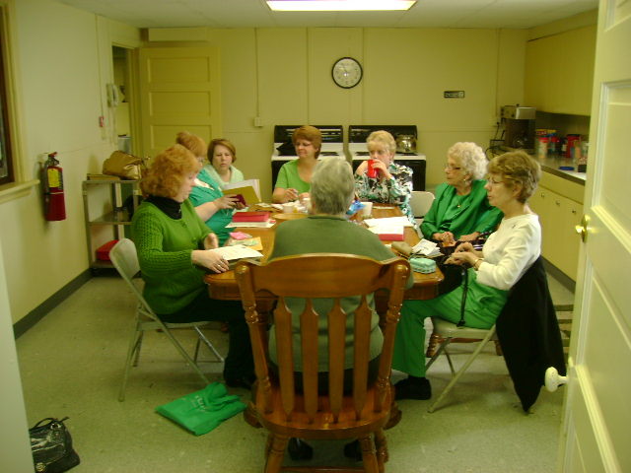

**OUR CONGREGATION**

**“We are Family!”**

In 1979, the music group Sister Sledge released their big hit “We Are Family!” The Island Christian Church is just that, family! We you walk through the door, you will feel the family atmosphere as you are welcomed with open arms. What better way to feel the love of God in times when you may be at your lowest, or celebrating your blessings… having an extended family to share it with.

We are part of the West Virginia Disciples of Christ region. Our mission statement is simple: “We are Disciples of Christ, a movement for wholeness in a fragmented world. As part of the one body of Christ we welcome all to the Lord’s Table as God has welcomed us.”

Along with the church Pastor, the Island Christian Church also has a Youth Program, that mentors all of our youth from the youngest to those even in college.

One on one ministering is also available for those that need that guidance and counsel when crisis enters their lives.

**COMMUNITY OUTREACH**

**“Helping Those in Need”**

The Island Christian Church continues to be very active within the Island community as well as with the many charities in the Wheeling area. Outreach programs during the church year have provided needed items as well as volunteers. Some of those include:

* Catholic Charities
* House of the Carpenter
* Wheeling Soup Kitchen
* St. Luke’s Church Christmas Party
* Ohio County dog shelter
* Florence Crittenden Home
* Relay For Life
* Salvation Army

YOU ARE INVITED

“Family Members Have Different Interests”

Different Interests provides different ways to serve a church and our region and world:

***CWF (Christian Women’s Fellowship***: women of the church and the regions coming together for fellowship and serve.

***Disciples Men***: Men through the region working as one to continue to support, grow out church and region.

***Youth and Ministries & Christian Youth Fellowship:*** Youth programs within the church as well as camps and gatherings within the region for all ages.

***Disciples Mission Fund:*** provides   
operational funds for the Christian Church in West Virginia and General Units serving God in the USA and around the world.



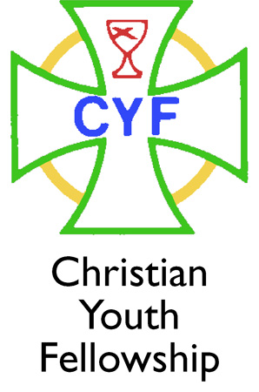





**BRIEF HISTORY OF THE**

**ISLAND CHRISTIAN CHURCH**

**(Disciples of Christ)**

"Sometime in 1897, Claude G. Hart, seeing some street urchins at play, invited them to his home and began a Sunday School. Here, the Island Christian Church had its humble origin." A canvass was made of 57 family homes on Wheeling Island on October 18, 1897, and on December 6 of the same year, a declaration was made stating the desire and intention to organize a new Church. Five months later on March 30, 1898, about one hundred persons signified their desire for a series of gospel meetings. A room was rented for permanent quarters and later house, reserving a room for the Sunday School and prayer services. Interest in the work grew rapidly, and converts were made. The congregation developed and prepared to build a new house of worship. The new church was completed and dedicated on April 17, 1902. In a short while new Sunday School rooms were added and by 1918 the membership had grown to 272. The most traumatic event of the first fifty years was the 1936 flood. Lost were the pipe organ, two pianos, carpet, pews, and all the church's records. In addition, considerable damage was done to the building itself.

Late in 1951 it was learned that the church was in the path of the Fort Henry Bridge that would eventually exit the planned Wheeling Tunnel and cross the Island to Ohio. Moving or demolishing the church were the only two available options. After long negotiations with the State, the decision was to move the building approximately 200 feet to the West where it stands today.

Truly the most traumatic event in the entire 100 year history occurred late in the evening of Saturday, June 14th, 1974. That was the night that an arsonist lit the insulation between the building and its siding, and after smoldering for some time, a raging inferno destroyed the structure, contents, and records of the Island Christian Church. The decision was made to demolish the entire structure above the sanctuary floor, and prepare the remaining basement to house the congregation. This was accomplished by November, and the first worship service back at 59 Zane was held on Thanksgiving Sunday.

The Island Christian Church has stood the test of time and tribulations and remains a strong presence on Wheeling Island.